## Track

<https://www.linearmotiontips.com/five-things-to-consider-in-vertical-applications/>

Components

* 80/20 T-slot channels to mount things whereever needed

Fastener

* 80/20 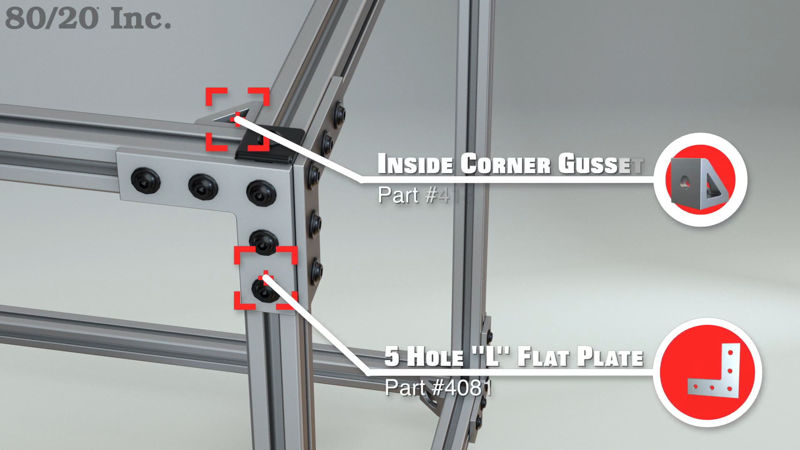

Alternative designs

* 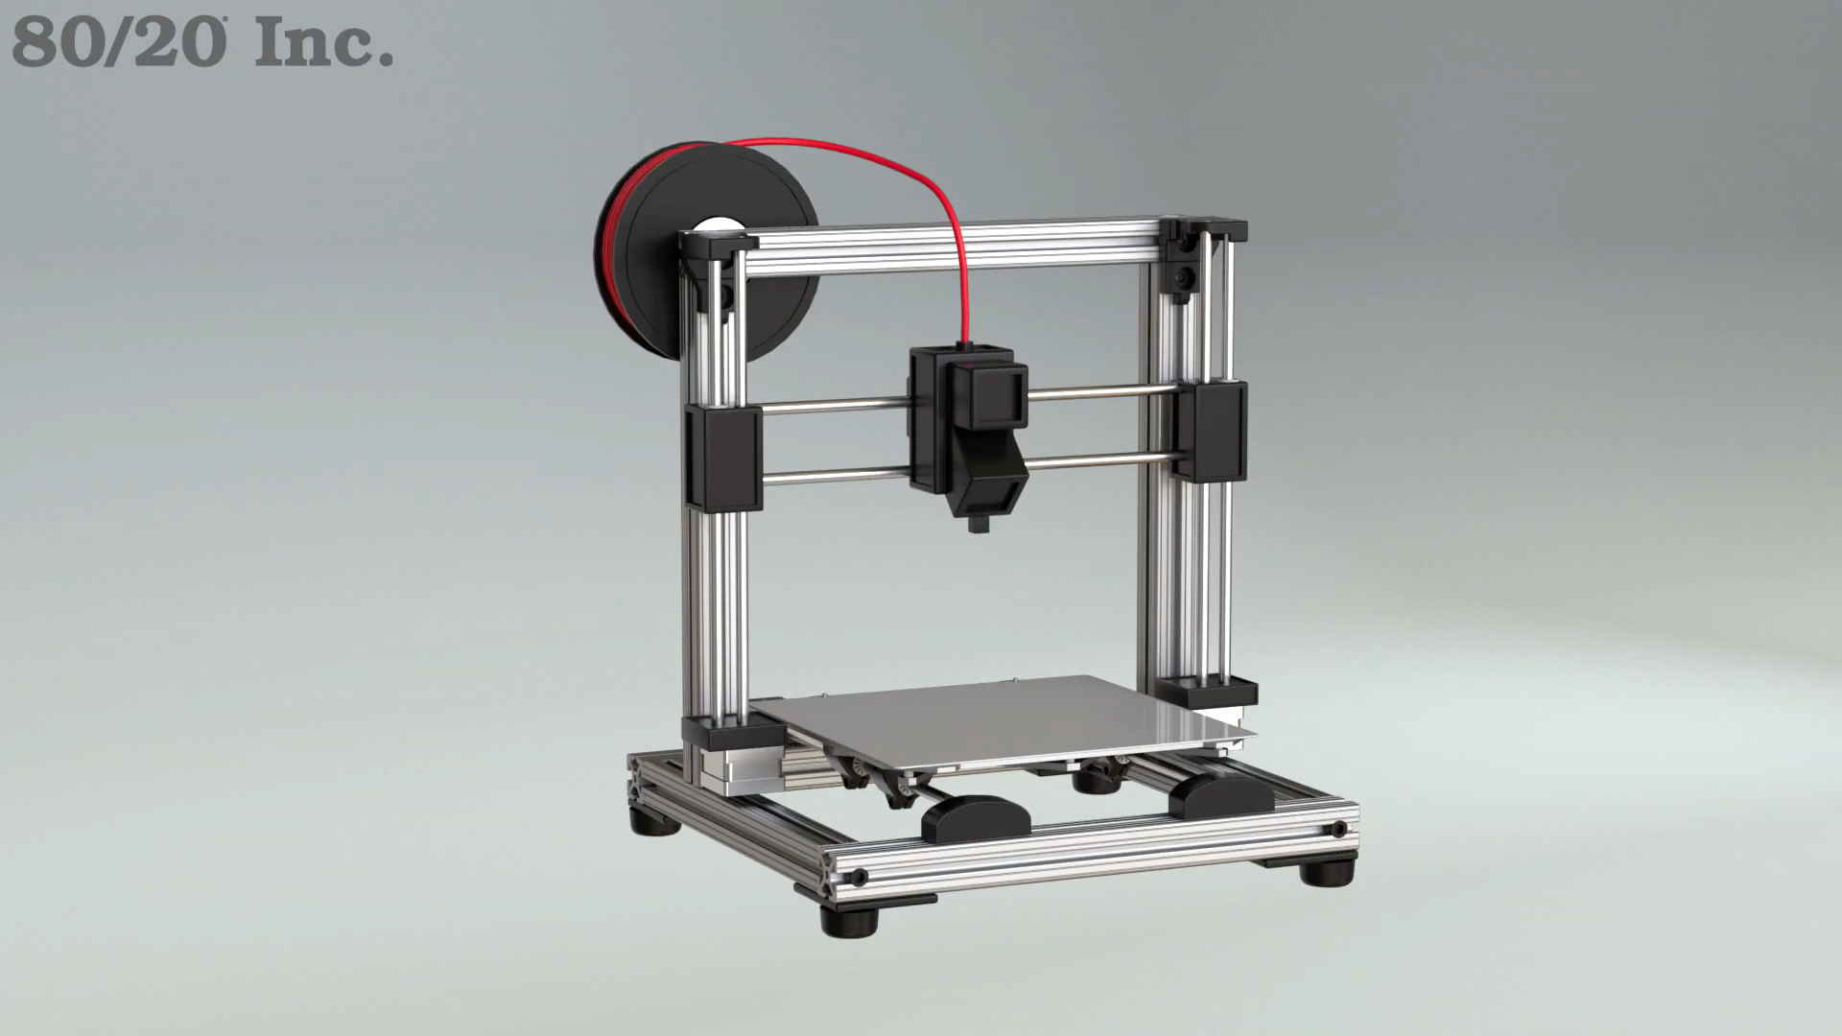
* 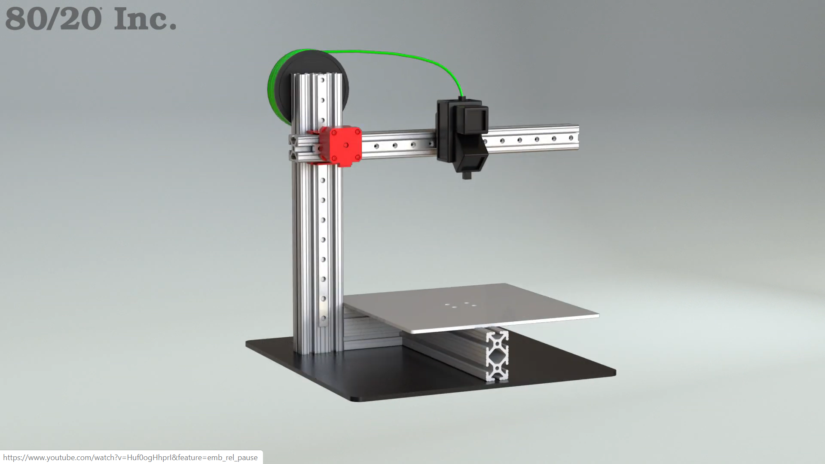

### Linear Motion

* Lead screws and stepper motor and flex coupler and thrust bearings and pillow block
  + Flex coupler reduce friction

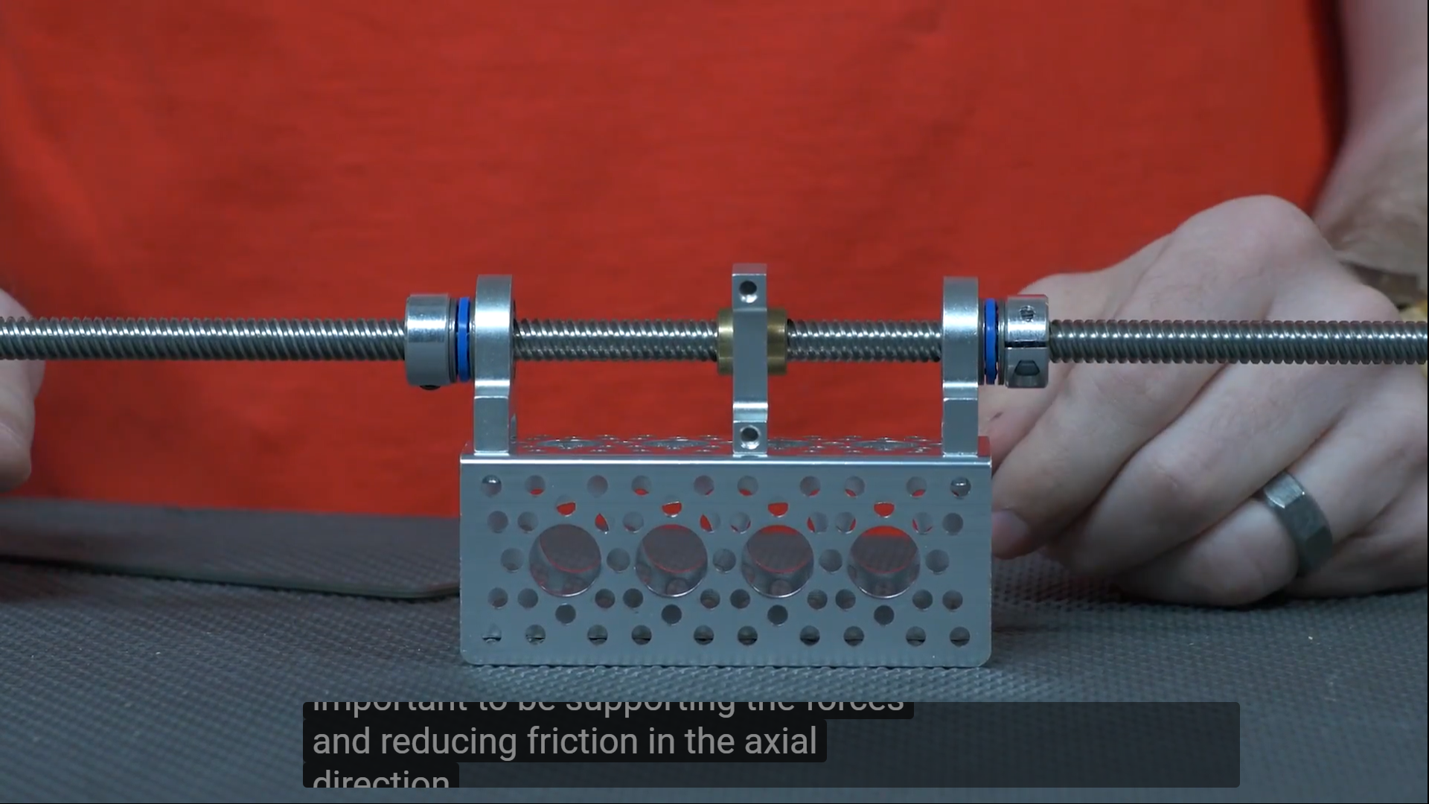

* Servo + servo block: takes the axial load from the servo motor and direct to exoskeleton
* Linear bearing

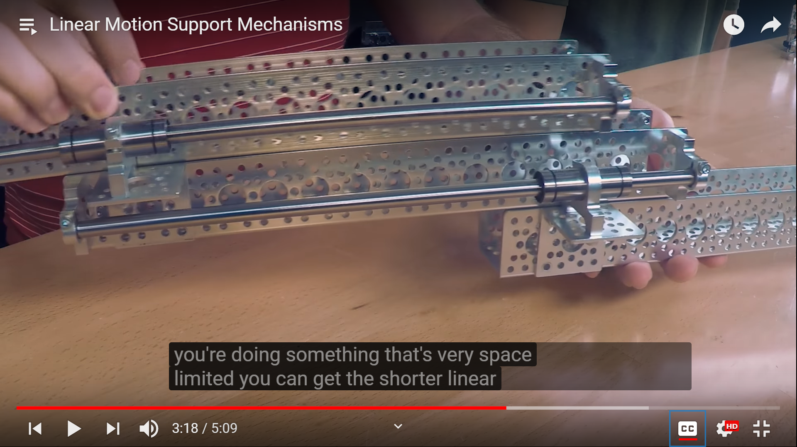

* Tube roller: may not be driving precisely due to slippage in some tubes

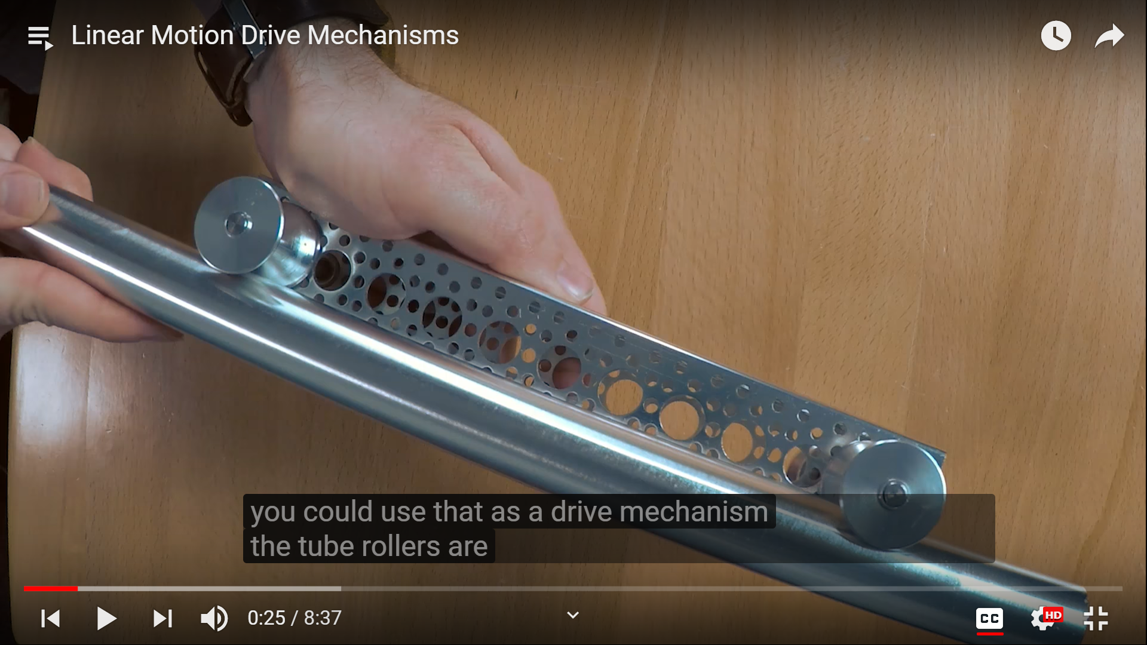

* Lead screws (not threaded rods as they are not manufactured for linear motion)
  + 8mm rod with 8mm pitch
  + Z axis is always a screw drive (WorkBee)
  + Maximum is 1000 mm, else you have to go to belt drive
  + Accuracy of 0.1 mm or greater,
  + Can undertake much higher load without affecting accuracy
  + Slower than belt drive
* Timing belt
  + Neoprene and fibreglass reinforced
  + Run on aluminum pulleys
  + Not limit how long, can run a lot quicker than the screw drive
  + Has an error of 0.2 mm

### General Links

Cheatsheet

* <https://www.instructables.com/id/Arduino-Claw-Machine/>
* file:///C:/Users/Richard/Downloads/Claw%20Machine%20v1%20BoM.pdf

Project outline

* <https://q.utoronto.ca/courses/130087/files/5807675?module_item_id=1181322>

### Aluminum structure

Design Elements

* 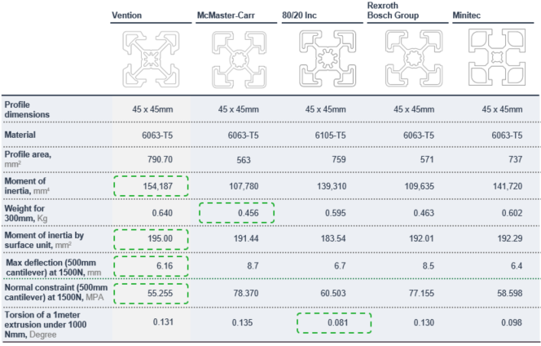
* <https://us.misumi-ec.com/pdf/fa/2012/p2_0493.pdf>
* <https://8020.net/product-basics>
* <https://www.servocity.com/>

Tips

* <https://www.vention.io/blogs/top-3-design-tips-for-effective-t-slot-aluminum-extrusion-structures-42>

Track

* Rail:
  + Aluminium extrusion single four slots rail 30x30mm hollow with 8mm T-slot
  + $9.76 X 6 + $17.31 X 4 = $127.8 (<https://www.mcmaster.com/aluminum-extrusions>)
  + $13.20 X 4 + $6.60 X 6 = $92.4 (<https://us.misumi-ec.com/vona2/detail/110302686450/?curSearch=%7b%22field%22%3a%22%40search%22%2c%22seriesCode%22%3a%22110302686450%22%2c%22innerCode%22%3a%22%22%2c%22sort%22%3a1%2c%22specSortFlag%22%3a0%2c%22allSpecFlag%22%3a0%2c%22page%22%3a1%2c%22pageSize%22%3a%2260%22%2c%2200000042719%22%3a%22a%22%2c%2200000042737%22%3a%22a%22%2c%2200000332720%22%3a%22600%22%2c%22fixedInfo%22%3a%22MDM00001301525110302686450-36090445-1255582776479363661%7c41%22%7d&Tab=wysiwyg_area_0>)
  + $13.29 X 4 + $7.62 X 6 = $98.8 (<https://8020.net/30-3030.html>)
  + CAD $12.50 X 4 + $6.50 X 6 = $89.0 (<https://www.fazstore.ca/product/10qe1010/>)
  + CAD $14.90 X 4 + $7.45 X 6 = $104.30 (<https://quickshop.rmmc.net/collections/10-series/products/1010?variant=27770944389184>)
  + 4 ft or 1.2 m should be needed for length, 2 ft or 60 cm for width, 2 ft ro 60 cm for height
  + Actual shape: One rectangle bottom, One three-sides rectangle layer, One three-sides bridge in front. Total: 4 ft X 4, 2ft X 6
* Fastener: corner bracket (economical, no machining needed)
* Caster
  + Two needed
* Linear motion track between top and bottom layer

## Overall Architecture

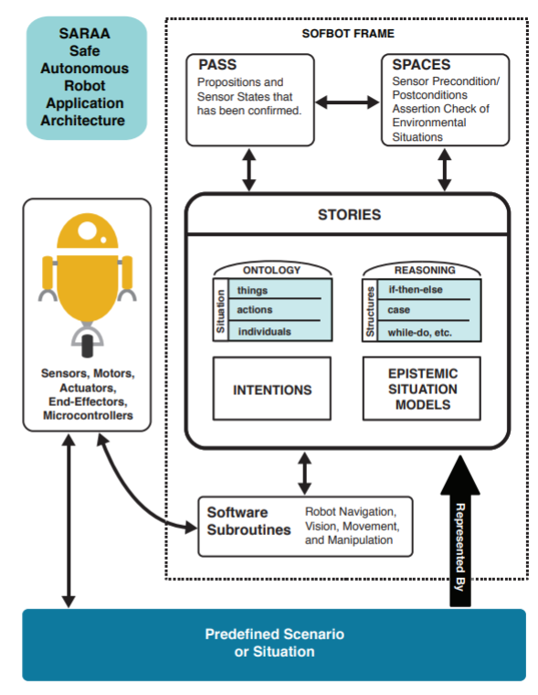

## Management

Dividing the project into subroutines

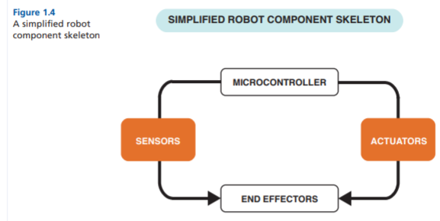

## Framing

“Softbot frame”

1. Parts
2. Actions (in steps)
3. Tasks
   1. e.g. locate the object in the room, determine its colour, and report
4. Scenarios/Situations
   1. e.g. Unit1 is located in a small room containing a single object. Unit1 is playing the role of an investigator and is assigned the task of locating the object, determining its color, and reporting that color.

Visual Planning

* Visuals used to help develop the plan of instructions for what the robot will do: floorplan of the physical environment of the scenario, statechart of the robot and object’s states, and flowcharts of the instructions for the tasks
* Make sure to include all the preconditions and postconditions and checks of whether it is okay for the robot to carry out current and next task

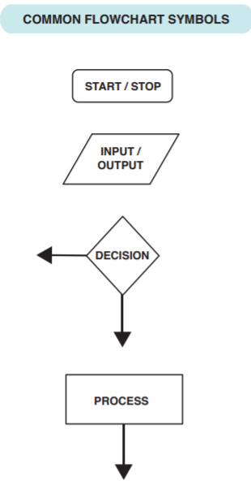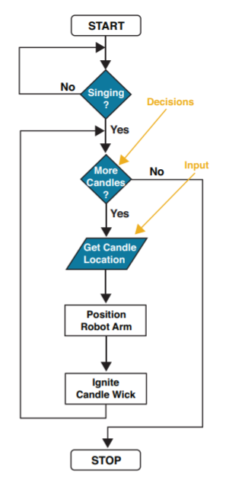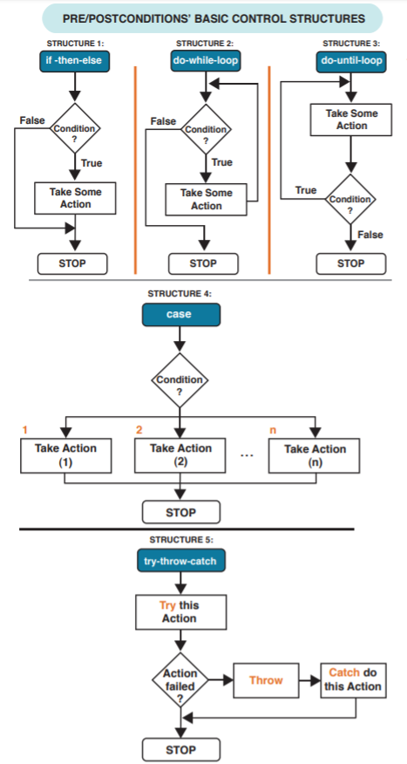

## Diverge/Converge

Types of Movement

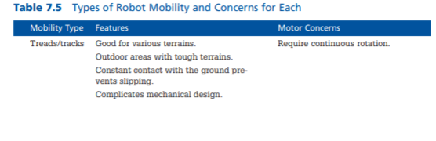

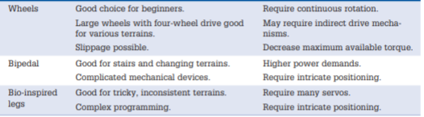

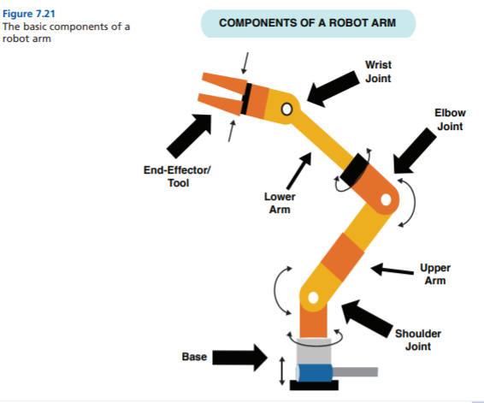

Types of end-effectors

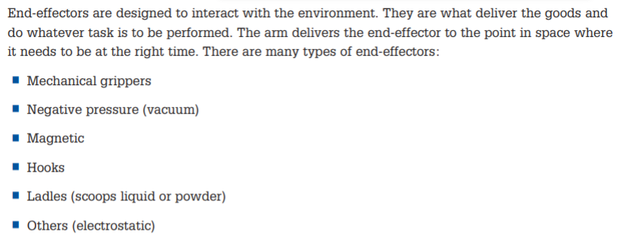

Types of microcontrollers

<https://docs.google.com/document/d/1VK4KU4xTywsna8z11uN1dJGDLdvasRhN6u28qptNcH4/edit?usp=sharing>

Types of sensors

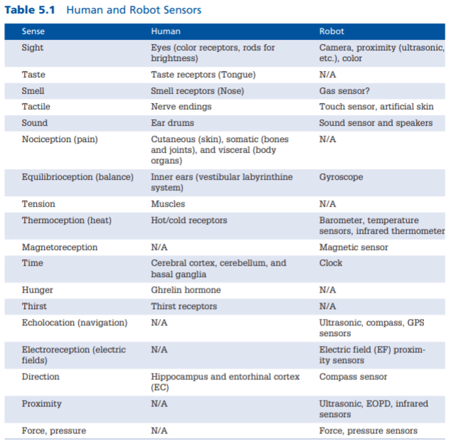

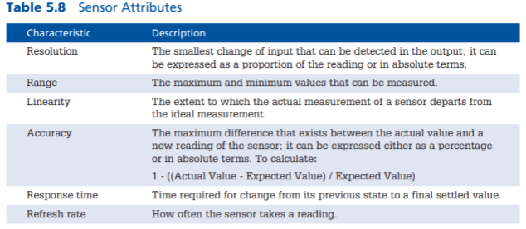

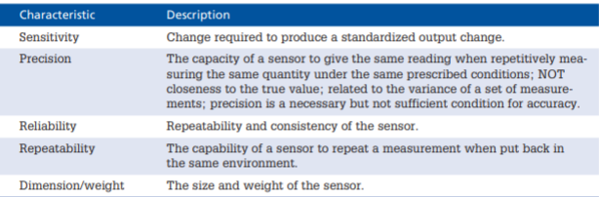

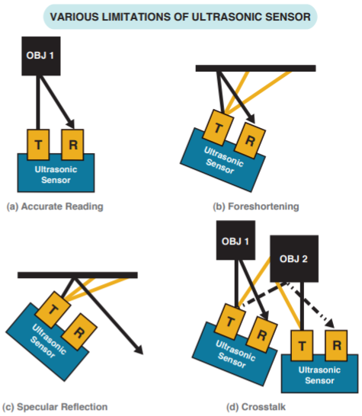

Types of motors

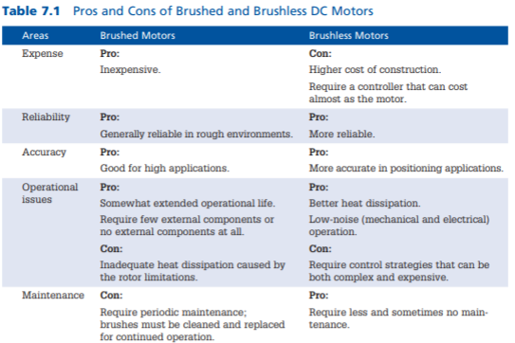

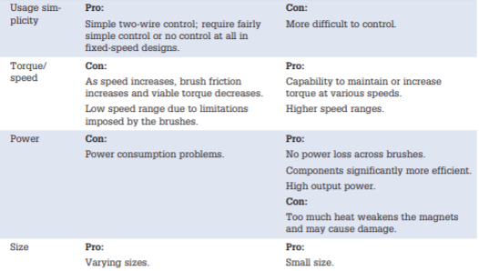

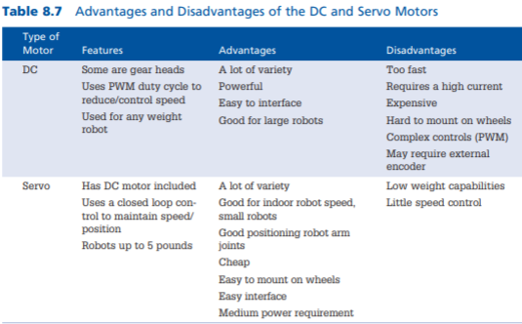

Use calculations to make sure each of the tasks can be executed by the components used in this checklist

* Sensor effectiveness/capability
  + At every decision point, use multiple sensors (if possible) for situation verification OR check those sensors against facts
* Actuator/mobility effectiveness/capability
  + For motors, read Gear Fundamentals (p178)
* End-effector effectiveness/capability
* Controller effectiveness/capability
* Communication effectiveness/capability

Capability Matrix

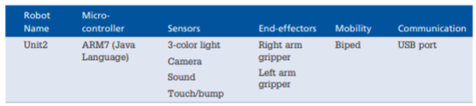

Spreadsheets

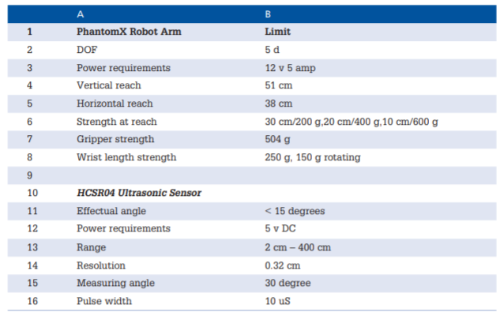

Torque and speed calculations

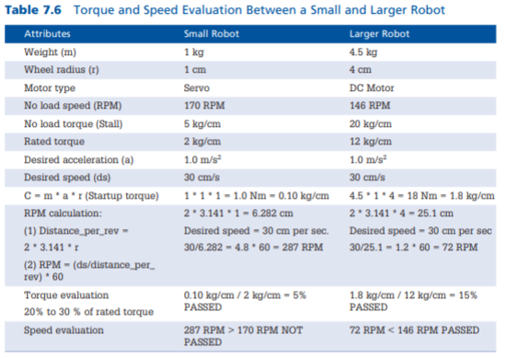

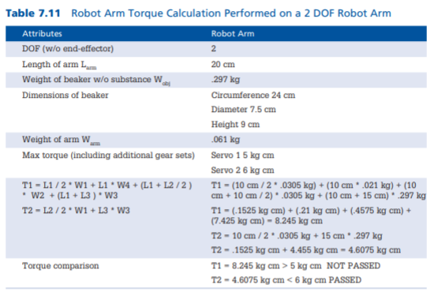

Coding

